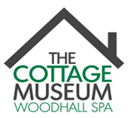
WOODHALL SPA COTTAGE MUSEUM
IDDESLEIGH ROAD, WOODHALL SPA, LN10 6SH

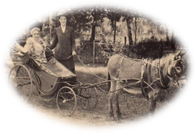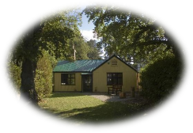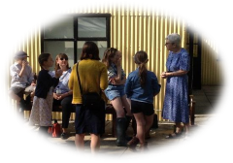

A SMALL MUSEUM WITH BIG SURPRISES!
OPEN FOR THE 2020 SEASON
SATURDAY 1st AUGUST – SATURDAY 31ST OCTOBER
10.30 am - 4.00 pm
THURSDAY, FRIDAY, SATURDAY, SUNDAY

DISCOVER A HIDDEN GEM OF LINCOLNSHIRE AND
EXPLORE THE UNIQUE HISTORY OF WOODHALL SPA

Dogs Welcome

VISIT THE TOURIST INFORMATION FACILITY AT
THE MUSEUM FOR INFORMATION ABOUT THE LOCAL AREA

Tel: 01526 352456 or email: info@cottagemuseum.co.uk
For more information visit our website: cottagemuseum.co.uk

