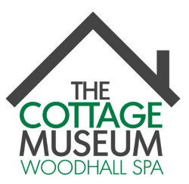

WOODHALL SPA COTTAGE MUSEUM

IDDESLEIGH ROAD, WOODHALL SPA, LN10 6SH

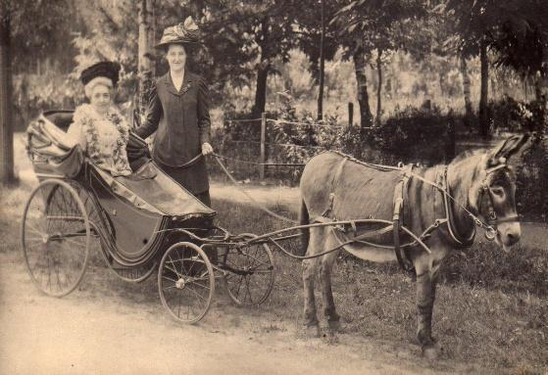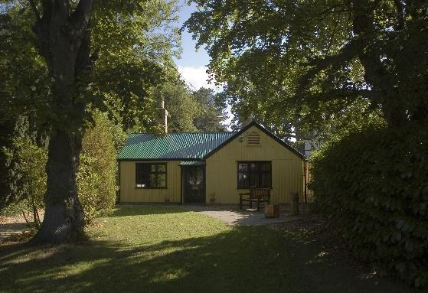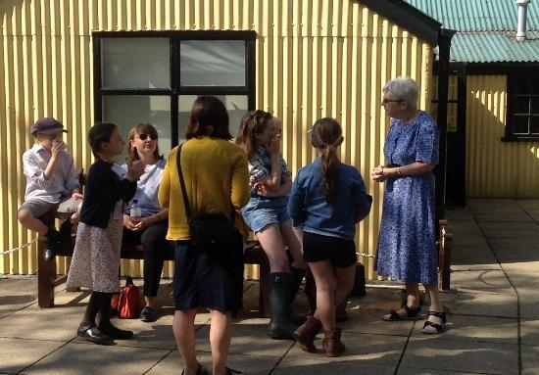

Additional Openings Days for HALF TERM week Tuesday 27th October and Wednesday 28th October.

10.30 am - 4.00 pm

DISCOVER A HIDDEN GEM OF LINCOLNSHIRE AND
EXPLORE THE UNIQUE HISTORY OF WOODHALL SPA

Dogs Welcome

VISIT THE TOURIST INFORMATION FACILITY AT
THE MUSEUM FOR INFORMATION ABOUT THE LOCAL AREA

Tel: 01526 352456 or email: info@cottagemuseum.co.uk
For more information visit our website: cottagemuseum.co.uk

