A talk on
Wolds Women of Influence

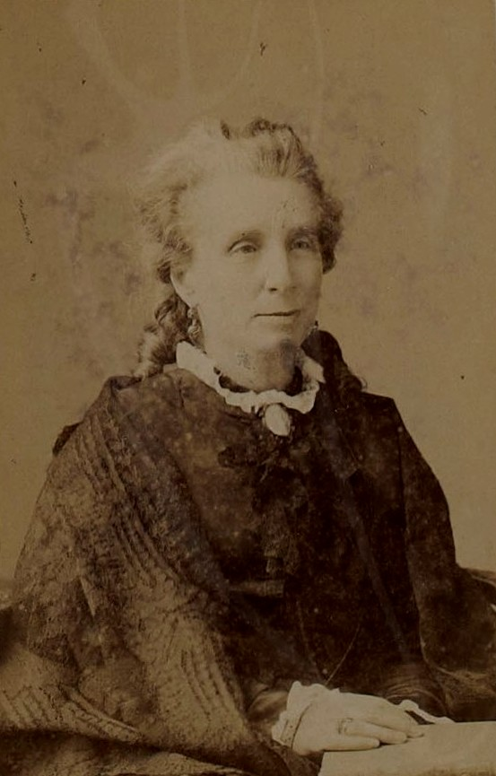

Tickets can be obtained from
the Golf Hotel Reception
or Reserved
by phone:
01526-352456
by e-mail:
info@cottagemuseum.co.uk

At the
Golf Hotel, Woodhall Spa on Saturday 6th April 2019 at 2.30pm
(doors open 2.00pm)

Interval with refreshments

Tickets £5

Featuring the lives and achievements of women from 19th and early 20th centuries who made their mark both nationally and locally.
