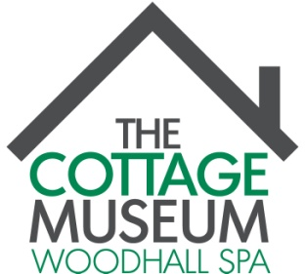

Volunteer Role Description
Role Title: | Visitor Services Volunteer
Role Purpose: | Delivering a friendly welcome and engaging with a diverse audience. This is a stimulating and flexible role that will develop as the museum grows.
Role Description:  (An Overview) | - Helping to provide a friendly and warm welcome to visitors arriving at the museum.  - Engaging with visitors inside the museum space.  - Answering general enquiries.  - Helping to promote the museum’s activities.  - Helping to maintain a safe environment.  - Selling admission tickets and dealing with shop sales.  - Recording sales and stock information on to the computer.  - Supporting guided tours.
Role Reports To: | Volunteer Co-ordinators - Gill Noble and Patricia Duke-Cox
Where: | Woodhall Spa Cottage Museum  Iddesleigh Road  Woodhall Spa  Lincolnshire  LN10 6SH.
When: | We expect volunteers to be able to commit to at least one half-day a month.  Friday morning 10.30am - 1.30pm or Friday afternoon 1.30pm - 4.30pm in high season.  Friday afternoon 12.30pm - 2.30pm or 2.30pm - 4.30pm in low season.  Interviews will be held on Friday 3rd March 2017.  Volunteers must be able to attend a group training session w/c 27th March 2017.
Duration: | 1st April 2017 - 29th October 2017
Qualities and skills we ask for: | - A friendly attitude and enthusiasm for interacting with members of the public.  - Ability to work as a part of a team.  - An interest in the history of the village and surrounding area and a willingness to learn about the history of the Museum.  - Flexibility and ability to use own initiative.  - Computer literate  The role is open to all. We expect to engage a team of 8 volunteers and we welcome applications from people of all abilities, backgrounds and communities.
Our Commitment to you: | As a Visitor Services Volunteer, you will have the opportunity to:  - Receive full training and support to fulfil the role.  - Develop your confidence and customer service skills.  - Learn about the history of the area and the Museum.  - Work as part of a team.  - Meet new people and take part in special activities organised for volunteers.  We will:  - Treat you and all volunteers equally and fairly.  - Respect you as an individual and treat you courteously.  - Ensure that you have a safe working environment.  - Listen to your concerns if things are not going right.  - Recognise that you are a volunteer and that you have other commitments.
What we want from you: | - To be the friendly face of the Museum and offer a warm and friendly welcome.  - Commit to the necessary training and give your time.  - Comply with our agreed policies and standards.  - Be professional and loyal to the Museum.  - Be fair and courteous to those around you.  - Talk to the Directors first if you have a problem.
How to apply: | To apply, please complete an Expression of Interest Form and either email it to: office@cottagemuseum.co.uk or post it to: Volunteer Co-ordinator, Woodhall Spa Cottage Museum, Iddesleigh Road, Woodhall Spa LN10 6SH.  Please mark the envelope “Private & Confidential”.  Deadline for applications is: Noon on Tuesday, 21st February 2017.

