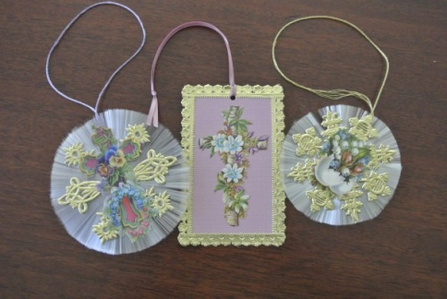
Vintage Easter Craft

29th March at 10am to 1 pm

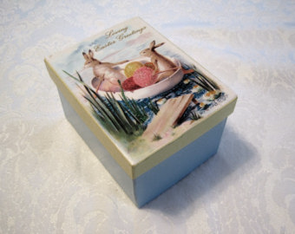
Spring craft activities with a vintage theme. Create your own unique seasonal cards, gift boxes and decorative items inspired by a myriad of colourful, imaginative and creative imagery from the late nineteenth and early twentieth centuries. Discover how the Victorians celebrated Easter, welcomed Spring and used the natural world to develop their artistic skills.

Beginners and experienced crafters all welcome.

Admission £7.50 to include all equipment, materials and an abundance of tea, coffee and biscuits!
Please book in advance by calling Gill Noble 01526 353455 or email info@cottagemuseum.co.uk Iddesleigh Road, Woodhall Spa, LN10 6SH

