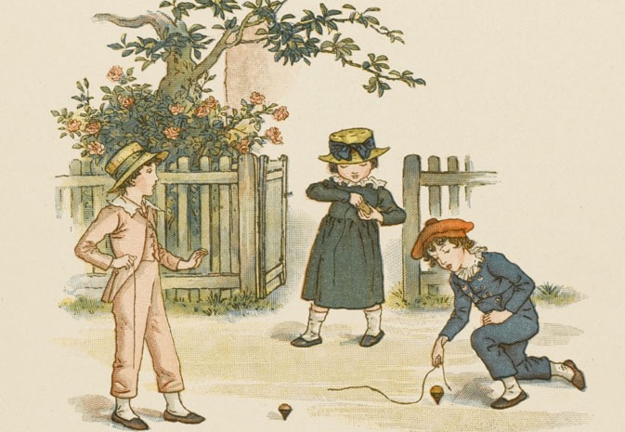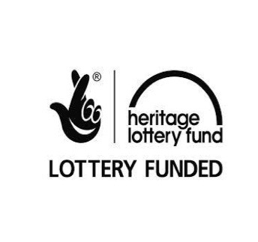

**The Cottage Museum**

Iddesleigh Road

Woodhall Spa

LN10 6SH

[**www.cottagemuseum.co.uk**](http://www.cottagemuseum.co.uk)

**TOYS AND**

**GAMES**

**T**

**Have fun finding out about Victorian children, playing with their toys and games and making a toy.**

**Wednesday 3rd August**

**10.00am - 12noon**

**£3 per child, children must be accompanied by an adult.**

**To book a place**

**01526 353455**