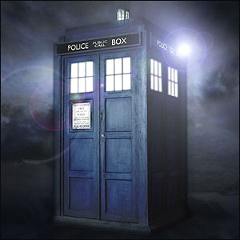

**The Cottage Museum**

Iddesleigh Road

Woodhall Spa LN10 6SH

**[www.cottagemuseum.co.uk](http://www.cottagemuseum.co.uk)**

50p to enter, normal museum admission charges apply £3.50 for adults, £3.00 concessions, no charge for accompanied children under16 years.

**TIME TRAVEL TRAIL**

Find the Time Machine

and time travel your way through the Museum.

19th July

to

8th September

10.30am - 4.00pm