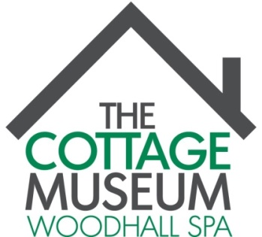
Registered charity: 1114268

WOODHALL SPA COTTAGE MUSEUM QUIZ EVENING
At the Abbey Lodge Inn
Saturday 9th April 2016 starting at 7.00 p.m.
[doors open at 6.30 p.m.]

Teams of 4 to 6 to compete in an evening
of letters, numbers, raffle and fun.

Tickets £10 per head which includes a bar meal
(choice confirmed with ticket)

If you can form a team contact
Patricia Duke-Cox at the Cottage Museum to register
or email/phone either of the following addresses

info@cottagemuseum.co.uk

duke-cox@hotmail.co.uk

or phone 01526 352456 (office) or 07944 487 880
All proceeds to Woodhall Spa Cottage Museum funds
Accredited Museum: 1929 Reg. Charity: 1114268 www.cottagemuseum.co.uk

