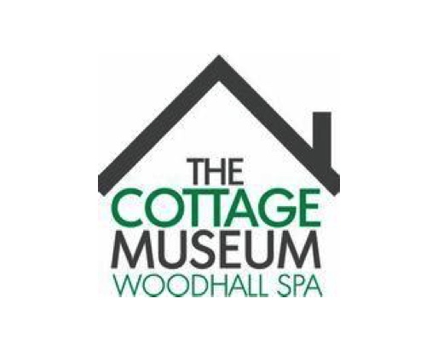

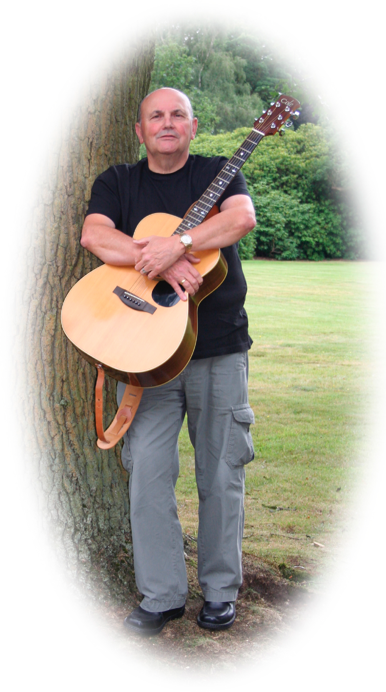

LIVE MUSIC IN THE GARDEN WITH ALAN BOLT

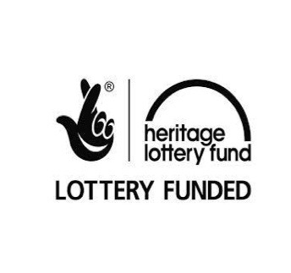

AUGUST 13th 2 pm to 4 pm

Donations are welcomed

Come along to the Cottage Museum to enjoy our free music in the garden session with the professional entertainer Alan Bolt. Alan performs a great mix of acoustic folk, country and pop from the 1950's & 1960's - Irish - Misc and oldies singalong.