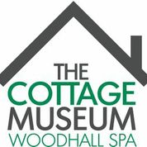 The Cottage Museum
Iddesleigh Road
Woodhall Spa LN10 6SH
Saturday 3rd December 3.00pm
‘Winter Wassail’
Explore the Museum decorated for a Victorian Christmas. At 3.00pm, find out about ‘Wassailing’ which takes place in the New Year. Join us in singing Carols and Wassail Songs around the Christmas tree.
Museum Open 1.00pm – 5.00pm
Admission charges: Adults £2.50 Concessions £2.00
Accompanied children free

Wassail themed drinks and refreshments on sale
Further details from www.cottage museum .co.uk

